***Prior to the opening of polls at 6:00 am, you must inspect and certify that this***

***polling location provides full ADA accessibility for all voters.***

Instructions to Board Workers:

Walk the path of travel to confirm there are no obstructions preventing ADA accessibility. This location requires temporary modifications and these remedies must be in place to provide full ADA accessibility at the polls. Use the photos to determine compliance. If you check NO to any of these questions, **please contact your County Board of Elections immediately.**

Compliant with

Temporary Measures

Yes No

Yes No

If off-street parking is available—is there at least one ADA accessible parking space marked with ADA accessible parking signs?

If off-street parking is available—Is the parking sign marked “van accessible”?

Is the path of travel to the front door free of any large cracks or holes?

Is the path of travel from the parking area to the voting area free of any obstructions?

Is there at least a 6 foot area in front of the sign-in table and the voting machines?

***If you checked NO to any of the above questions, please provide the name of the person you notified at your***

***County Board of Elections: ____________________________________________________________________***

Yes No

Yes No

Yes No

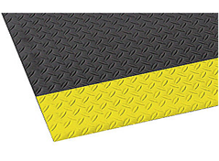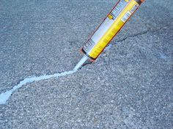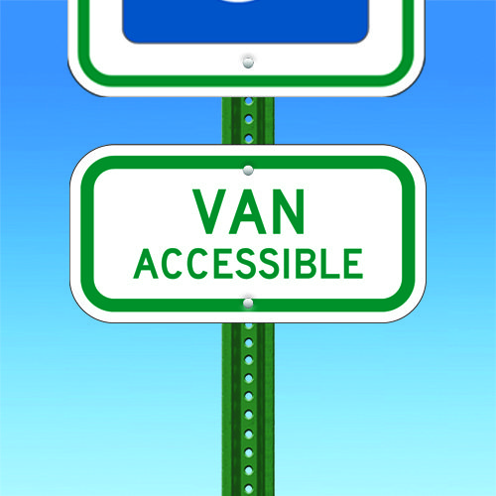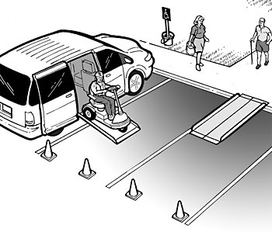

Yes No

Yes No

Yes No

Yes No

Yes No

Cones & ADA accessible parking sign are in place to create temporary ADA van accessible parking space.

*ED Notes: ___________________________________________________________________________________*

*____________________________________________________________________________________________*

*ED Notes: ___________________________________________________________________________________*

*____________________________________________________________________________________________*

*ED Notes: ___________________________________________________________________________________*

*____________________________________________________________________________________________*

*ED Notes: ___________________________________________________________________________________*

*____________________________________________________________________________________________*

*ED Notes: ___________________________________________________________________________________*

*____________________________________________________________________________________________*

“Van Accessible” sign has been posted in the ADA accessible parking space.

Any large cracks or holes are filled or covered by a slip resistant mat to provide a stable and firm surface.

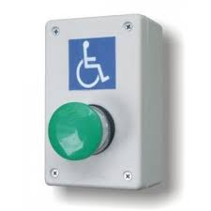

A temporary ramp has been installed over steps or high thresholds.

A temporary doorbell has been posted outside to remedy a non-compliant ramp or entrance issue.

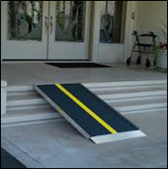

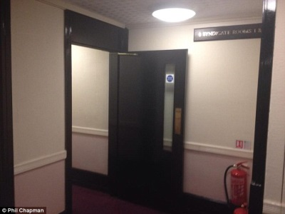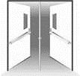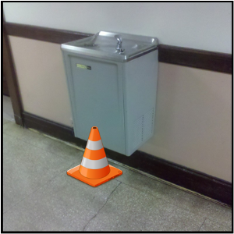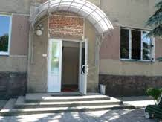

Yes No

Yes No

Yes No

Yes No

Yes No

*ED Notes: ___________________________________________________________________________________*

*____________________________________________________________________________________________*

*ED Notes: ___________________________________________________________________________________*

*____________________________________________________________________________________________*

*ED Notes: ___________________________________________________________________________________*

*____________________________________________________________________________________________*

*ED Notes: ___________________________________________________________________________________*

*____________________________________________________________________________________________*

*ED Notes: ___________________________________________________________________________________*

*____________________________________________________________________________________________*

The interior entrance is non-compliant and the door must be propped open.

The middle bar is removed in doorway to expand width of opening.

A cone or other object is placed underneath the object that extends more than 4” into the path of travel.

Other issue:

The exterior entrance is non-compliant and the door must be propped open.

**Election Day Certification**

*I/we hereby certify that the above identified polling location has been inspected and found compliant for ADA accessibility. All temporary modifications are in place providing fully ADA accessibility at this polling location.*

*I/we certify that the foregoing statements made by me are true. I/we are aware if any of the foregoing statements made by me are willfully false, I am subject to punishment.*

______________________/_________________________ _______________________/_________________________

Boardworker Printed Name / Signature Boardworker Printed Name / Signature

______________________/_________________________ _______________________/_________________________

Boardworker Printed Name / Signature Boardworker Printed Name / Signature

**Master Board Worker Verification** _________________________________________ Page 2

***This polling location has been inspected & determined to be in compliance by the County Board of Elections with the above temporary modifications. If an unforeseen event creates an ADA inaccessible condition, please contact your County Board of Elections immediately.***